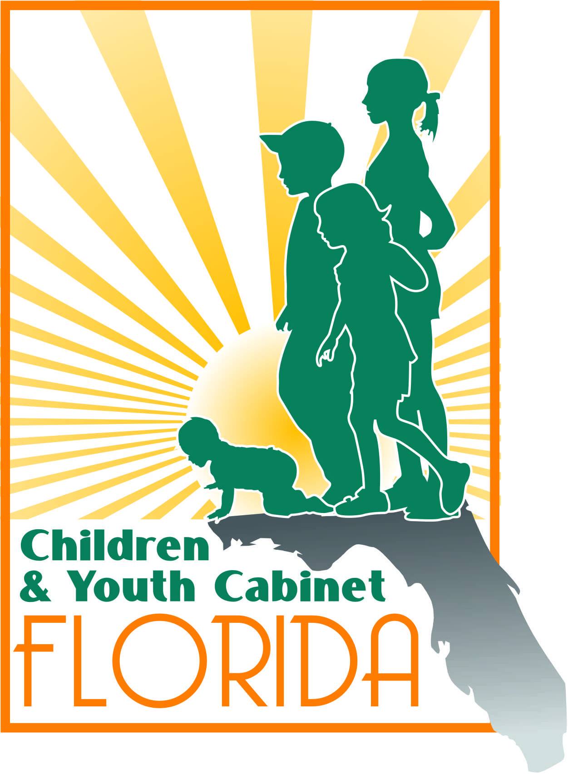
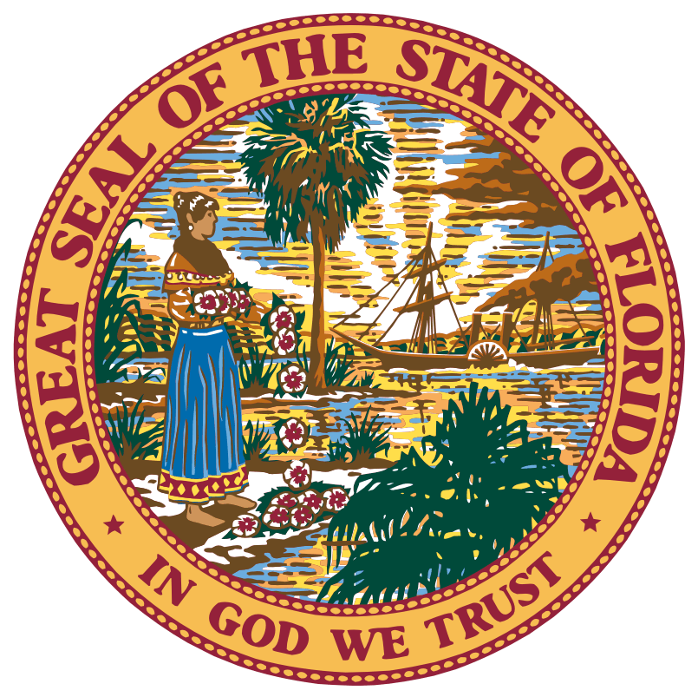
Florida Children and Youth Cabinet Meeting
August 7th, 2018
8:30 a.m. – 12:30 p.m. EST
North Collier Regional Park
15000 Livingston Rd.
Naples, FL 34109

Meeting Summary

Note: The following is a summary of the highlights of the proceedings and is not intended to be construed as a transcript. To obtain meeting materials, please visit www.flgov.com/childrens-cabinet.

Attendance Summary

FCYC Members in Attendance:

- Chair Wansley Walters
- Senator Lauren Book
- Secretary Mike Carroll
- Secretary Christy Daly
- Director Zackary Gibson
- Judge Sandy Karlan (Ret.)
- Erin Smeltzer (for Director Rodney MacKinnon)
- Vice Chancellor Jacob Oliva (for Commissioner Pam Stewart)
- Justice Barbara Pariente
- Jeff Smith (for Director Barbara Palmer)
- Dr. Celeste Philp
- Diana Ragbeer
- Tanya Wilkins
- Victoria Vangalis Zepp

Staff in Attendance:
- Lindsey Zander
- Pat Smith

Meeting Start: 8:45am
Meeting End: 12:25pm

Proceedings
Call to Order and Welcome
Chair Wansley Walters called the Florida Children and Youth Cabinet (Cabinet) meeting to order and welcomed Cabinet members.

The roll was called by Lindsey Zander and quorum was confirmed.

Chair Walters introduced Senator Lauren Book who represents the Broward County-based District 32 as the newest member to the Cabinet. Senator Book shared a few words and expressed her appreciation and excitement to work with the fellow members of the Cabinet.

Chair Walters announced that this will be Secretary Daly’s last Cabinet meeting and applauded the tremendous work that she has accomplished during her tenure as Secretary of the Department of Juvenile Justice (DJJ). Secretary Daly expressed that she is very proud of all the accomplishments at DJJ over the last several years and she will miss being a member of the Cabinet.

Chair Walters acknowledged the letter written by Justice Barbara Pariente included in the member’s meeting packets. The letter commended the work of both Secretary Mike Carroll and Secretary Christy Daly on addressing the needs of children involved in both of their systems (crossover youth). Justice Pariente applauded the work and progress of both DJJ and DCF on their work and commitment to these crossover youths.

Chair Walters thanked Dr. Mimi Graham for allowing the Cabinet to be a part of the Dr. Vincent Felitti “Think Tank” event held on Monday, August 6th. Dr. Graham thanked the Cabinet for their participation at the event. The purpose of this Think Tank was to showcase the work that is being done across the different systems regarding Adverse Childhood Experiences (ACEs). Justice Pariente suggested that as a Cabinet, the respective agencies (DCF, DJJ, etc.) could look at each assessment that is done for children that are brought to the court (ACE score). Victoria Zepp would like to include information on ACEs on the Cabinet’s portal in order to share information around children’s issues.

2018 KIDS COUNT Data Book
Dr. Norin Dollard presented on the 2018 KIDS COUNT Data Book. The Annie E. Casey Foundation collects this data using national data sources on the 16 indicators of child well-being so that states can be compared directly. Florida currently ranks 34th in child well-being.
Secretary Carroll noted that the larger states with more diversity tend to be lower in ranking. The diversity in these larger states goes a long way in driving these numbers. Dr. Philip of the Department of Health (DOH) asked if there was a concept with race ethnicity adjusted data – whether or not there is a method to take into account the diversity of the population. Dr. Dollard advised that information does not currently exist.
Diana Ragbeer presented on some of the examples she has seen while working in the field. She noted that poverty is a result of something else happening; she says we need to identify ways to make a difference in that area. Affordable housing is another big driver as it relates to poverty. For example, she said, some people cannot afford to live in Monroe County - they will live in Miami-Dade and commute to work in Monroe County every day. She also emphasized the importance on getting the word out about KidCare, early childhood education and VPK enrollment. Ms. Ragbeer encouraged the Cabinet’s Communications Committee to share this information with the public through social media and through the Cabinet’s website.
Judge Sandy Karlan, Chair of the Policy Impact Committee, suggested each agency include a ribbon on their website, or a logo under their email signature with important notes, for example: “remember to enroll your child in VPK”, or, “get your immunization before school starts” etc.
Justice Pariente suggested that a pilot be created where the Cabinet hones in on five areas that are in most need around the state to determine what we could do to provide quality early childcare education and evaluate them for ACEs.
Erin Smeltzer informed the Cabinet that the Office of Early Learning is currently doing a data analysis – child care access index – where they are partnering with the University of Florida. They have only been able to cover five areas around the state, but they are continuing the study to determine if there is access to quality care. This could be helpful information to determine whether or not there is quality care in the area, if it is just a parent-choice issue, or if there is an issue to accessing care in general.

Action Item 1: Once OEL gets their baseline from HB 1091 with their class scores, they can share this information with the Cabinet.

Secretary Carroll noted the progress that Florida has been making and suggested that as we continue this progress, we start to work more intensely in those neighborhoods and zip codes that have not seen progress like other areas around the state. Dr. Philip agreed with Secretary Carroll and believes that more granular data will tell a different story. Director Gibson suggested that the Cabinet look into mapping.
Action Item 2: The Policy Impact Committee will bring back to the Cabinet where we need to go and what areas we need to focus on.

Empowering Families Project: How integrated data and community feedback loops will strengthen family outcomes in Broward County
Victoria Zepp, Chair of the Technology Workgroup Committee, introduced Dr. Laura Ganci with the Children’s Services Council (CSC) of Broward County and H. Kay Howard with Third Sector Capital Partners. The CSC Broward recently received the competitive, national “Empowering Families” grant from the Social Innovation Fund. The two-year grant funds training from Third Sector Capital Partners and Actionable Intelligence for Social Policy, as well as participation in a national Learning Community with other grant recipients. Ms. Howard and Dr. Ganci expressed their appreciation of the Cabinet’s support to continue the Broward data collaborative vision in which they hope to create a system with real time data to make decisions and have conversations with their providers to improve the outcomes in their communities.
Justice Pariente asked how many families they have served. Dr. Ganci said in 2017 they served close to 70,000 families. Across the kinship program, they served in the thousands. Justice Pariente asked if there are any plans to collect ACEs information. Dr. Ganci stated in 2015, they started utilizing different trauma screenings - some use the ACE, others use the life stressors survey, etc. - across all of their family strengthening programs, maternal depression programs and kinship programs. This would occur during their intake process so that they better know what types of services these families may need so they may provide referrals. Justice Pariente asked if judges were aware of these services. Dr. Ganci said they have made presentations to the delinquency judges and child welfare judges. Justice Pariente suggested they expand it as a general presentation. Director Zack Gibson inquired about the sheriffs’ offices and Dr. Ganci indicated they needed to continue their outreach to them.

Children and Families: “The Elite DNA Approach”
Philip Cirrone, Chief Operating Officer of Elite DNA Therapy Services, presented to the Cabinet on Elite DNA’s approach. This multi-disciplinary service provider was established in 2013 to serve the southwest Florida area. Elite DNA provides psychiatric evaluations and prescription maintenance, psychotherapy, specialized treatment for children with autism, including Applied Behavior Analysis and speech and occupational therapies. The goal of this approach is to manage psychological, emotional and behavioral issues before a family member has hit rock-bottom. This model serves as a “one-stop-shop” as it allows clinicians to evaluate a client’s situation in its entirety.
Secretary Carroll previously toured the Elite DNA facility and expressed how impressed he was with the level of integration because so many issues that they deal with are so prevalent in the DCF system. He expressed how important it is for folks to be able to navigate these systems and to be able to address the issues in one stop. Secretary Carroll would like to see this as the model for Florida moving forward – it is a culture and level of integration that he can’t say enough about. Justice Pariente asked what percentage of foster kids Elite DNA serves. Mr. Cirrone stated it is a small percentage due to the volume of kids that they see on a daily basis. Victoria Zepp asked how they envision their model solving the problem of folks having a limitation with toxic trauma training. Mr. Cirrone said they want to continue to be innovative as treatments change, therefore they bring outside trainers in to train their therapists.

Florida 2Gen Partnerships
Dr. Brittany Birken, CEO of Florida Children’s Council (Council), presented to the Cabinet on Florida 2Gen Partnerships. There is a growing recognition in Florida that systemic approaches are needed to simultaneously address the needs of both families and children in poverty, which is known as the two-generational approach, or 2Gen. Poverty is the single greatest threat to children’s well-being. Dr. Birken noted that childcare is more expensive than housing.
With growing recognition of the need for systemic approaches to strengthen resources and supports for families in poverty, coordinated strategies on social system development improvements and reform will be critical to maximize the policy opportunities that will be emerging in the next several years. The Council has expanded work and collaboration with state agency leadership, the Florida Chamber, and other key partners to improve public policies and increase coordination of services that would better support children and families in poverty. Through the analysis of current policies for social services, the Council has documented the presence of “cliff effects” for families in poverty. The analysis documented three key benefits cliffs that impede the pathway to economic security for families with young children in poverty: children’s health insurance, child care and housing.
The Council is launching a project called Families’ Ascent to Economic Security (FATES). With leadership from the Florida Children’s Services Councils, CareerSource Florida, and Early Learning Coalitions in four counties (Broward, Palm Beach, St. Lucie, and Martin) as well as philanthropic organizations, Florida is now implementing a demonstration project to better integrate child care and workforce services. Dr. Birken explained that by aligning these services, they can create a better outcome for families. The Kellogg Foundation has provided the initial grant funding for the Council to do a community demonstration project. It is a three-way partnership in those four communities, which consists of a local CareerSource entity, a local early learning coalition, and the CSC.
The Council would like to create a framework and a policy lens that would objectively allow us to evaluate this model, rather than taking a stand on a certain policy being proposed. The purpose is to objectively determine if proposed policies will work for families with young children, or if the policy will create unintended barriers or consequences.
Dr. Philip wanted to know, through the demonstration work in these four counties, if there has been an assessment - if they increase the number of kids, or what the capacity is for high-quality programs. She also wanted to know if there is a possibility to include promoting earned income tax credit as one of the strategies and how that might impact the work. Dr. Birken responded that this is where the model meets reality. She said they are going to honor parent choice first and foremost, but they will ensure that the parent is educated on the importance of quality, the options available to them, and ensure they are working with the Early Learning Coalition on providing support. If the center is lower quality than they want, there are supports offered to increase the quality. For families not tied to their center, they will use the baseline data and information that they receive, or existing data to direct those families to high-quality care. As it relates to child assessment, they look at the level of toxic stress for the child and their social/emotional development. The earned income tax credit is not part of the model, but it is something that can certainly be incorporated into the work.
Judge Karlan asked for further clarification on what the Cabinet can do to assist the Council in their efforts. Dr. Birken suggested the creation of an objective filter: any policy change that is contemplated during the legislative session will be evaluated by the objective criteria – this then becomes information back to the legislature so they can make more educated policy decisions.
Justice Pariente asked if any of the legislators in those four counties have been involved in the FATES project, as well as the Council’s relationship with businesses and communities in those areas. Dr. Birken stated they have a very close relationship with the business community in all of the CSC communities as well as the members of the legislature. She said their demonstration project will begin in two months, and the state policy work that they will be focused on is being geared up for the next legislative session. Justice Pariente asked Dr. Birken to continue to keep the Cabinet updated.

Lutheran Services Florida
Shareet Peninno, Executive Director of Lutheran Services Florida (LSF) in the southwest region presented to the Cabinet on all that Lutheran Services encompasses. LSF exists in 38 counties across the state to meet increasingly diverse needs. LSF serves over 500,000 people with over 60 social services programs. LSF is one of seven behavioral health Managing Entities contracted by the Florida Department of Children and Families to manage the state-funded system of behavioral health care for people who face poverty and are without insurance. LSF partners with Head Start and Early Head Start programs, protects the vulnerable via guardianship services, facilitates AIDS care and education, ensures safe and secure housing, and provides assistance to human trafficking victims, among many others services.
Secretary Daly applauded the Florida Network of Youth and Family Services which is one of the largest prevention providers in the state serving tens of thousands of kids every year through shelters and nonresidential programs. She also mentioned a program called Stop Now and Plan which provides guidance for children with behavioral problems, and their parents, on how to make better choices in the moment. Last year, the program received funding to expand statewide. She also commended the Human Trafficking screening tool that was developed and used in the shelters.

Public Comment
Nadereh Salim, CEO of Children’s Network of Southwest Florida serves 2,500 kids daily. Ms. Salim highlighted two prevention programs that they are currently working on. The first program is regarding teen pregnancy prevention. The Children’s Network discovered the Wyman Teen Outreach Program which empowers youth with at-risk behavior to reduce those behaviors. The Children’s Network received funding from the legislature and became a replication site. As of today, they have served over 1,000 youth and 100 percent of those youth have not become pregnant or contributed to a pregnancy.
The second program is a family mentoring program that is funded through money they received from the legislature. The Children’s Network has partnered with United Way who recruits volunteers for them. United Way trains the volunteers and matches them with families that are being reunified with their children. They have trained 176 volunteers and they have served 250 children and 200 families.

Closing
The next Children and Youth Cabinet Meeting will take place in late October or early November in Tallahassee, Florida.

Adjournment
Chair Walters adjourned the Florida Children and Youth Cabinet meeting at 12:25 p.m.

